Terraform 06
1. Watch the Terraform-06 video.
1. Terraform Modules
- A module is a collection of .tf files used together
- Every Terraform configuration is a module
- Root module → main working directory
- Child module → reusable module called using module {}

- Module Structure
- main.tf → resources
- variables.tf → input variables
- outputs.tf → outputs
- versions.tf → Terraform & provider versions

- Calling a Module
- Uses module block
- Requires source argument

- Module Inputs & Outputs
- Inputs passed using variables
- Outputs accessed as module.<name>.<output>

- Module Sources
- Local path
- Terraform Registry
- Git repository
- S3 / HTTP

- Module Best Practices
- Keep modules small and focused
- Do not hardcode values
- Avoid provider configuration in child modules
- Use version constraints
- Make modules environment-agnostic

2. Terraform Workspaces
- A workspace allows multiple state files for the same configuration
- Default workspace name: default
- Same code, different state

- Why Workspaces?
- Manage multiple environments
- Quick switching between environments
- Reduce code duplication

- Workspace Commands
- terraform workspace list
- terraform workspace new <name>
- terraform workspace select <name>

- Workspace Usage
- Workspace name accessed using terraform.workspace
- Commonly used for environment-specific values

- State Behavior
- Each workspace has its own state file
- Local backend → separate state files
- Remote backend → separate state keys

- Limitations of Workspaces
- Not recommended for production
- Weak environment isolation
- Risk of accidental changes
- Same backend and credentials

- Modules vs Workspaces
- Modules → code reusability
- Workspaces → state separation
- Modules organize infrastructure
- Workspaces separate environments (limited use)
2. Execute the script shown in the video.
- Terraform Modules:
Module is a collection of configuration files in a directory

- We can create Ec2 for different environments so that we can create a directory for aws_instance configuration

main.tf
resource "aws_instance" "webserver" {
ami = var.ami
instance_type = "t2.micro"
}
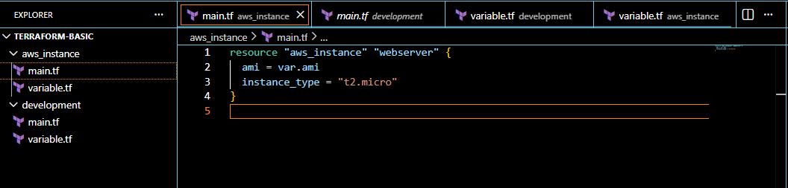
variable.tf
variable "ami" {

}
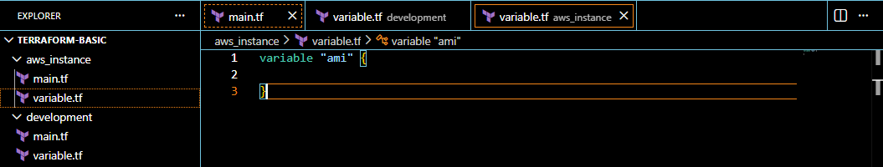

- Similarly we can create directory for development environment under root directory

main.tf
module "dev-webserver" {
source = "../aws_instance"
ami = "ami-07ff62358b87c7116"
}
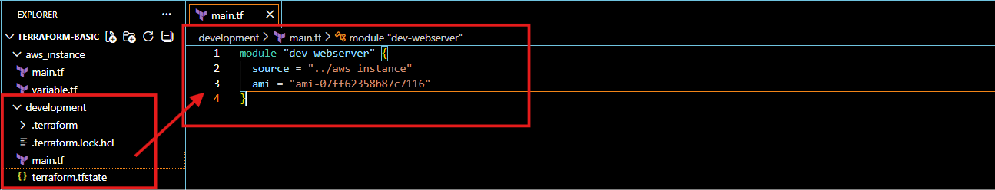
- Save and execute in terminal below commands
- terraform init
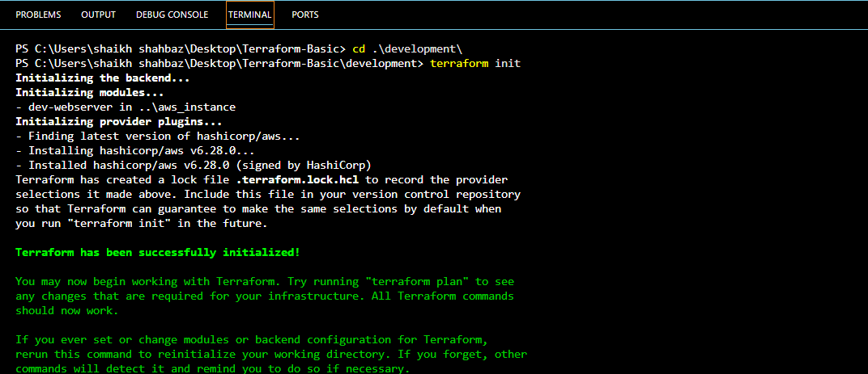
- terraform apply
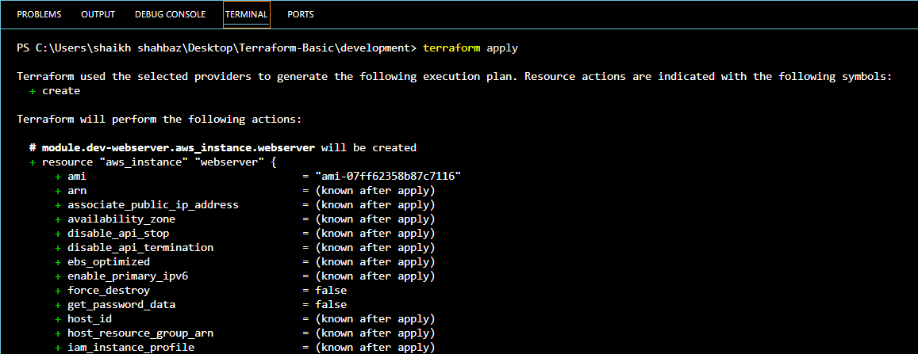
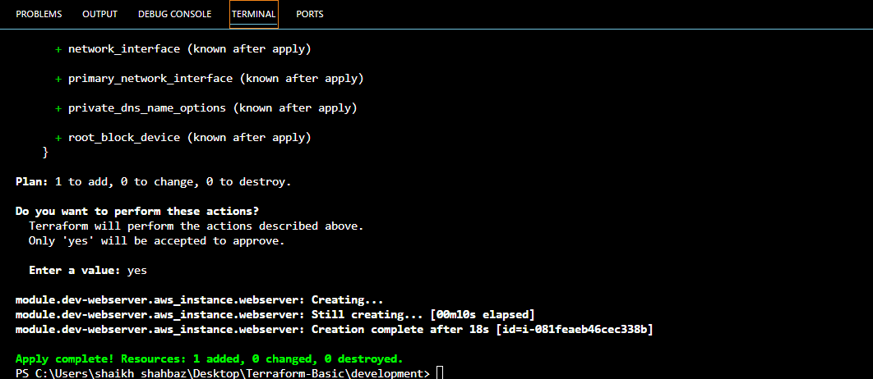

- Now we can check in our AWS account in Ec2
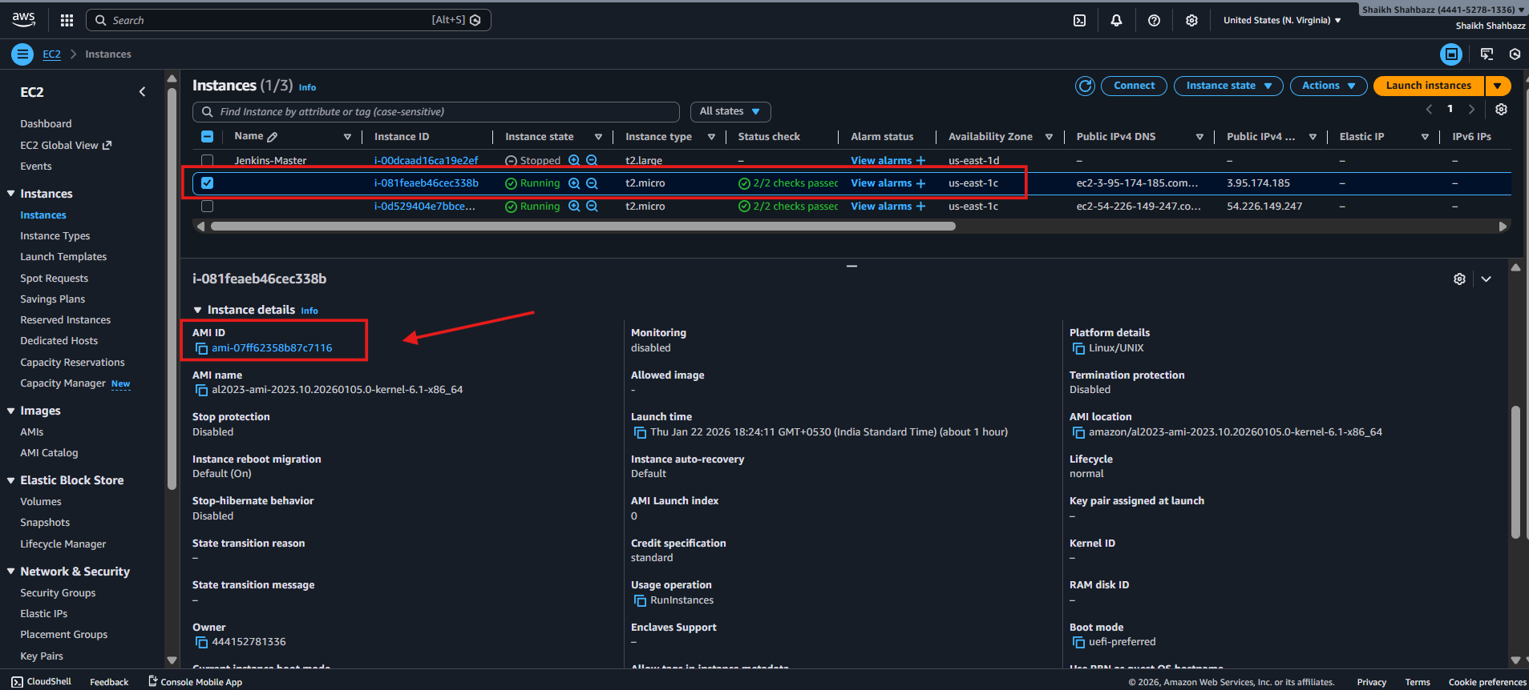

- Terraform Workspace
- Workspace can be used if we have multiple project/environments using the same configurations
- terraform workspace new projectA to create a workspace names projectA
- terraform workspace list to list the workspaces available
- terraform workspace select projectA to switch to specific workspace

main.tf
resource "aws_instance" "webserver" {
ami = var.ami
instance_type = "t2.micro"
}
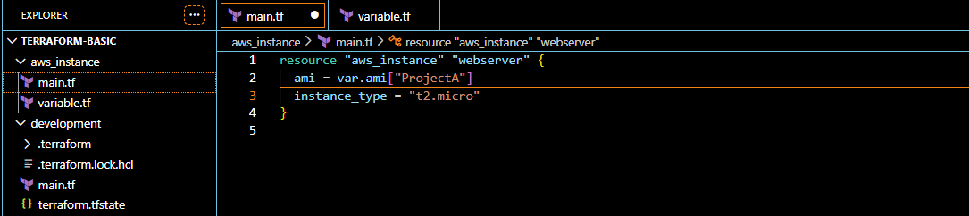

variable.tf
variable "ami" {
type = map(string)

default = {
"ProjectA" = "ami-07ff62358b87c7116"
"ProjectB" = "ami-07ff62358b87c7116"
}
}
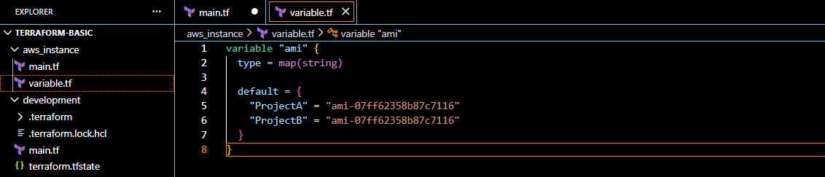

- terraform workspace new projectA < to create a workspace names projectA >
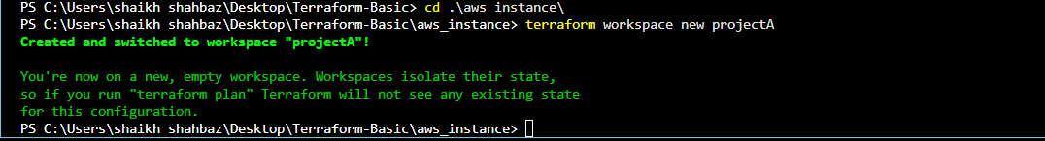
- terraform workspace list < to list the workspaces available >
- terraform workspace select projectA < to switch to specific workspace >
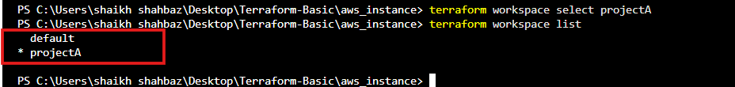
- terraform init
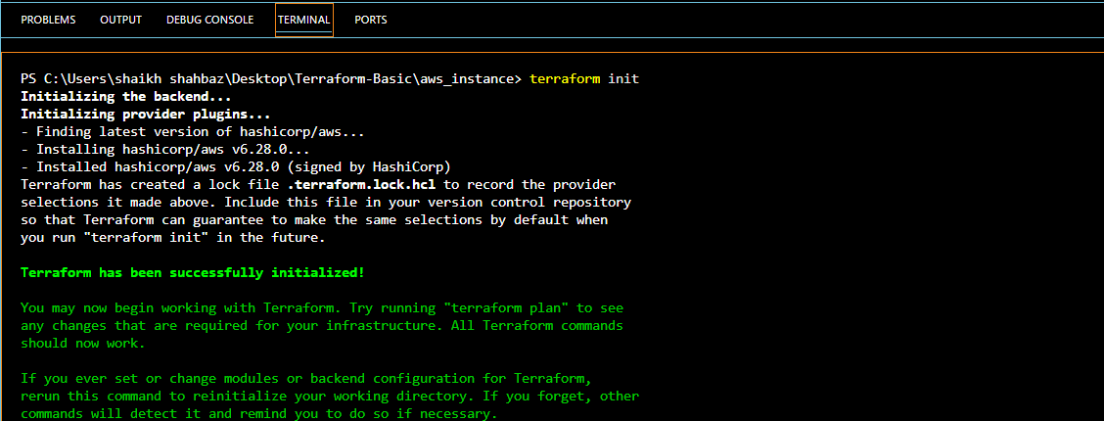
- terraform apply
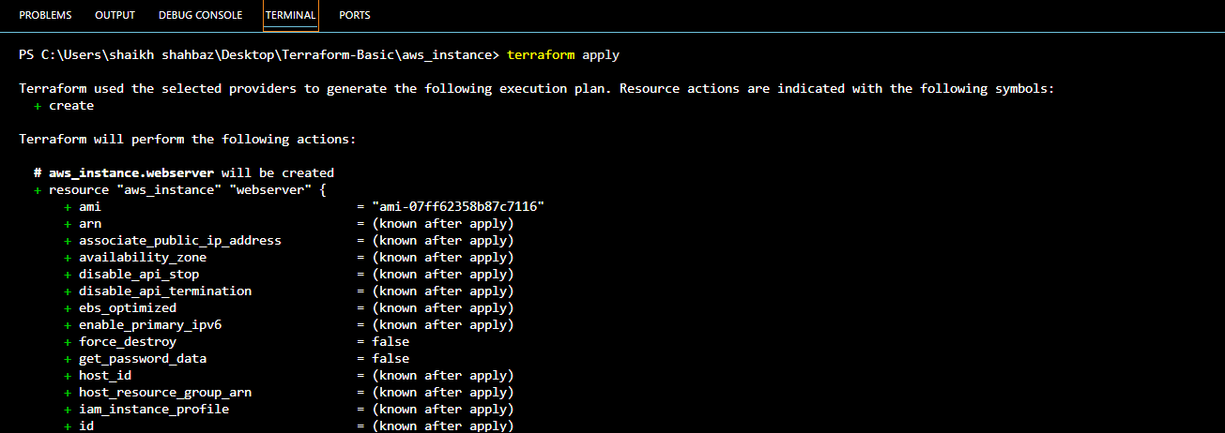
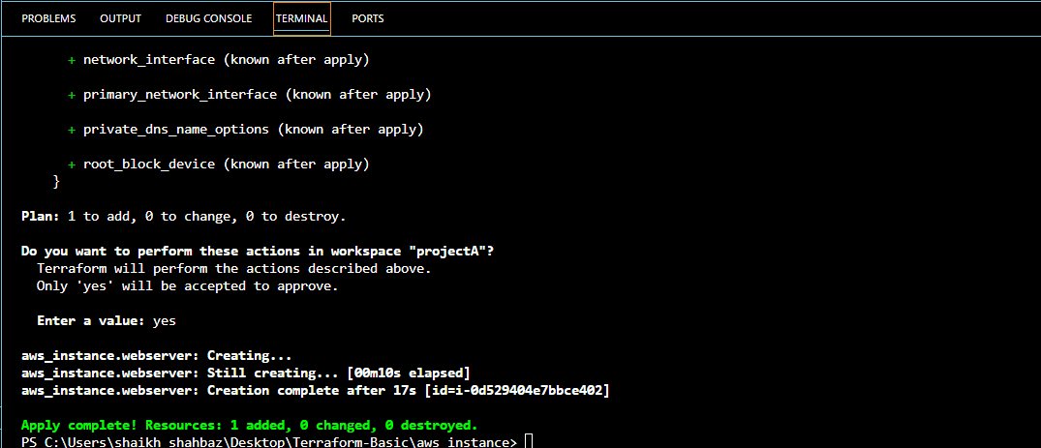
- Now we can check in our AWS account in Ec2

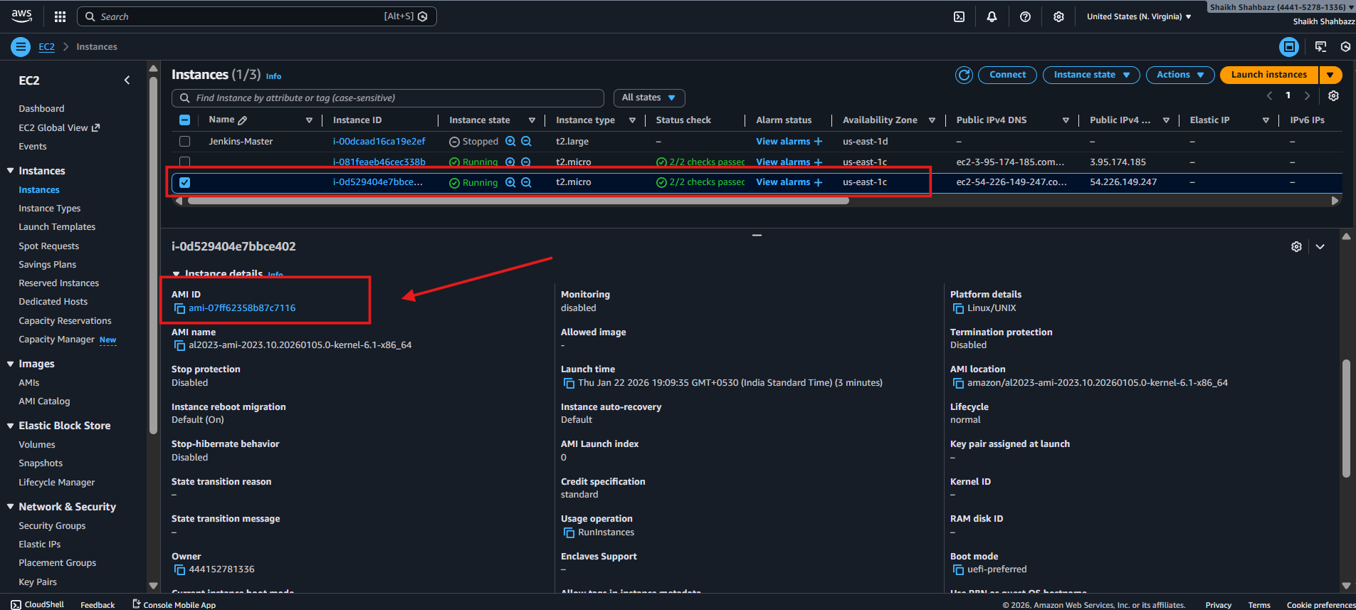
3. Provision EC2, S3, and VPC using Terraform modules.
main.tf
terraform {
required_version = ">= 1.3.0"

required_providers {
aws = {
source = "hashicorp/aws"
version = "~> 5.63"
}
}
}

provider "aws" {
region = "us-east-1"
}

# ----------------------------
# VPC MODULE
# ----------------------------
module "vpc" {
source = "terraform-aws-modules/vpc/aws"
version = "5.1.2"

name = "my-vpc"
cidr = "10.0.0.0/22"

azs = ["us-east-1a", "us-east-1b", "us-east-1c"]

private_subnets = ["10.0.0.0/26", "10.0.0.64/26", "10.0.0.128/26"]
public_subnets = ["10.0.1.0/26", "10.0.1.64/26", "10.0.1.128/26"]

enable_nat_gateway = true
single_nat_gateway = true
enable_vpn_gateway = false

tags = {
terraform = "true"
environment = "dev"
}
}

# ----------------------------
# EC2 MODULE
# ----------------------------
module "ec2" {
source = "terraform-aws-modules/ec2-instance/aws"
version = "4.3.0"

name = "my-ec2"

ami = "ami-07ff62358b87c7116"
instance_type = "t3.micro"

subnet_id = module.vpc.public_subnets[0]

associate_public_ip_address = true

tags = {
terraform = "true"
environment = "dev"
}
}

# ----------------------------
# S3 MODULE
# ----------------------------
module "s3" {
source = "terraform-aws-modules/s3-bucket/aws"
version = "4.1.2"

bucket = "shahbazz-s3"

tags = {
terraform = "true"
environment = "dev"
}
}

# ----------------------------
# OUTPUTS
# ----------------------------
output "vpc_id" {
value = module.vpc.vpc_id
}

output "ec2_public_ip" {
value = module.ec2.public_ip
}

output "s3_bucket_name" {
value = module.s3.s3_bucket_id
}
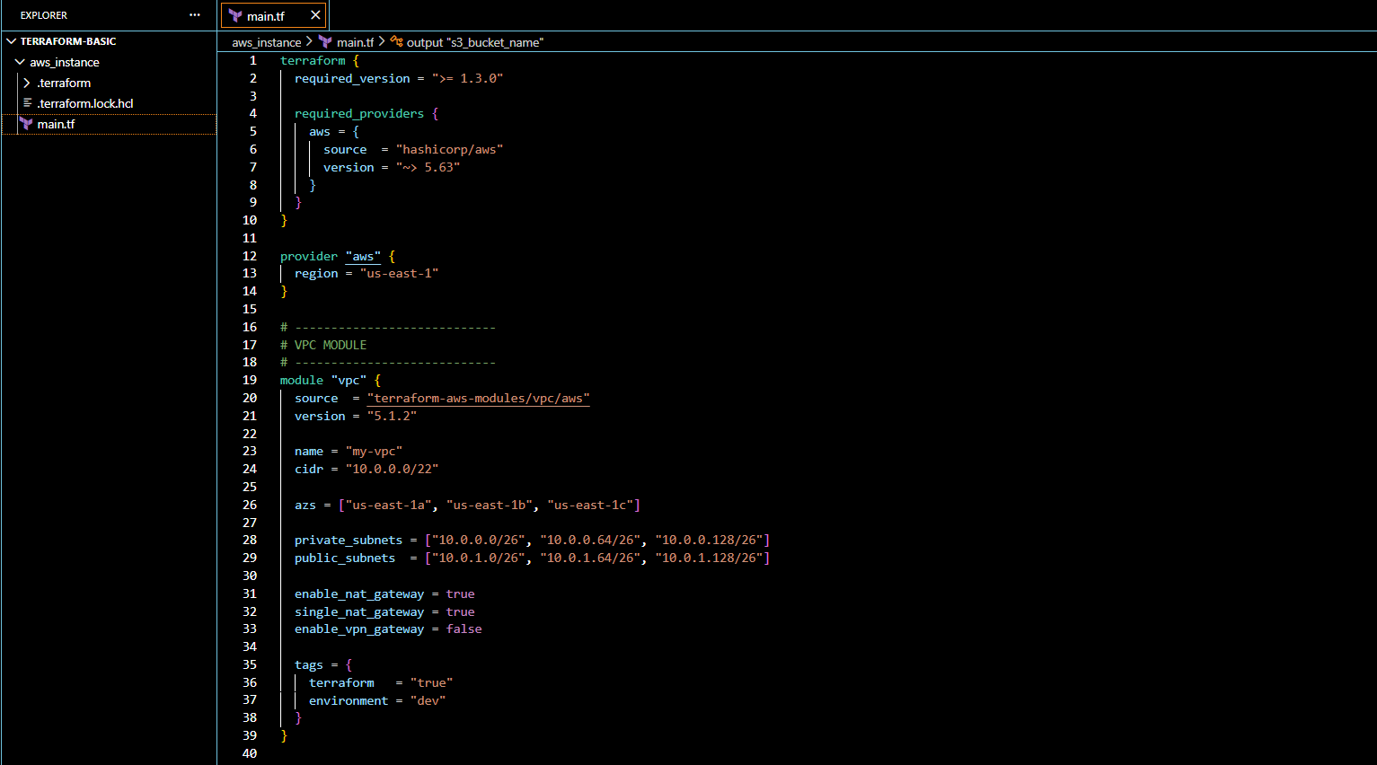
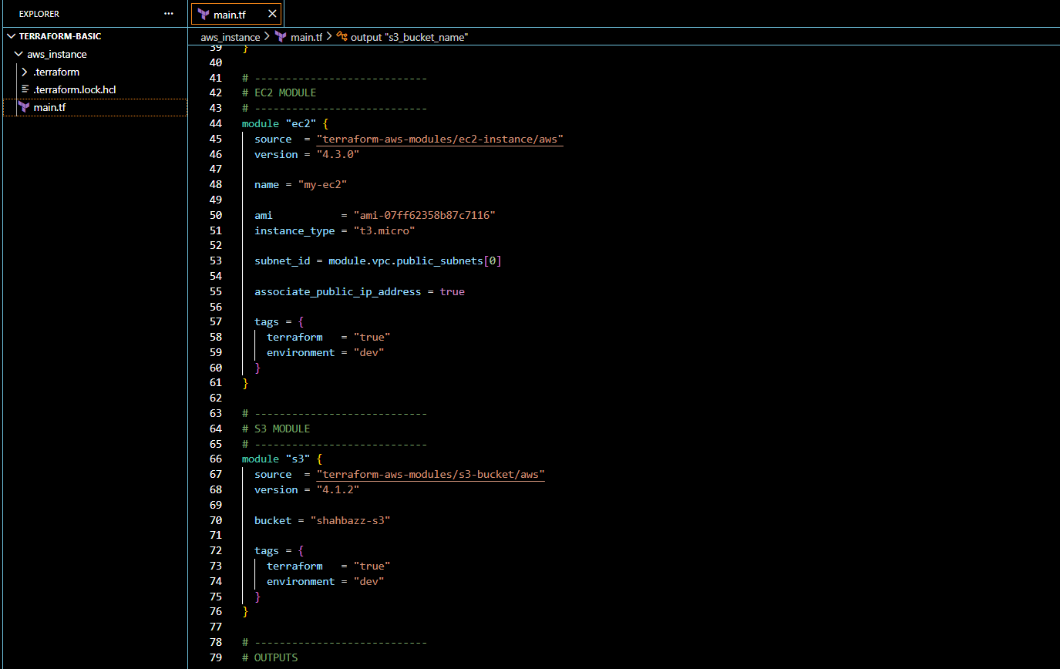
- terraform init
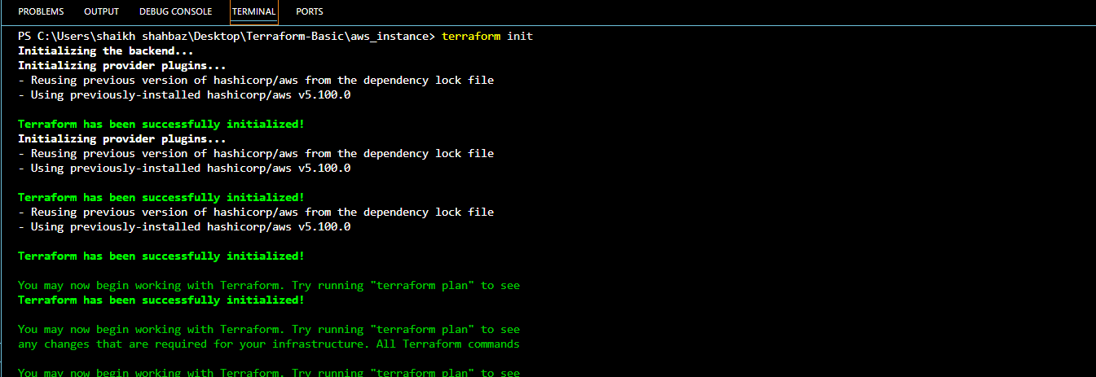
- terraform plan
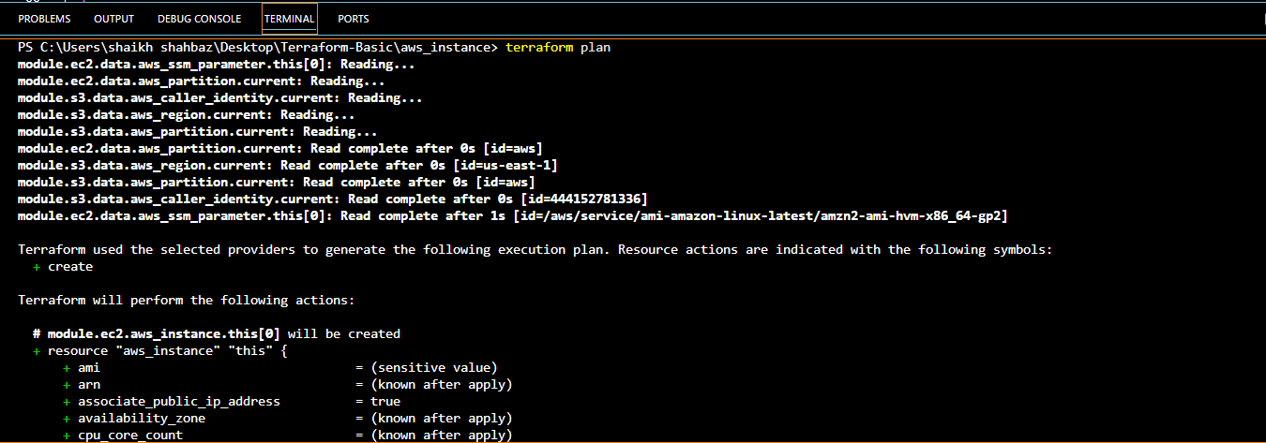
- terraform apply
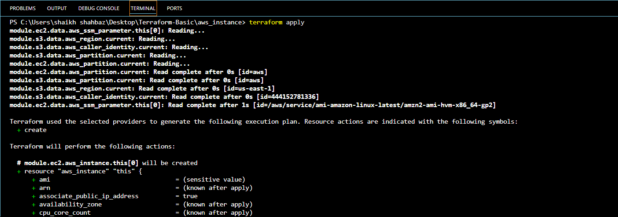
- we can see Terraform output in terminal
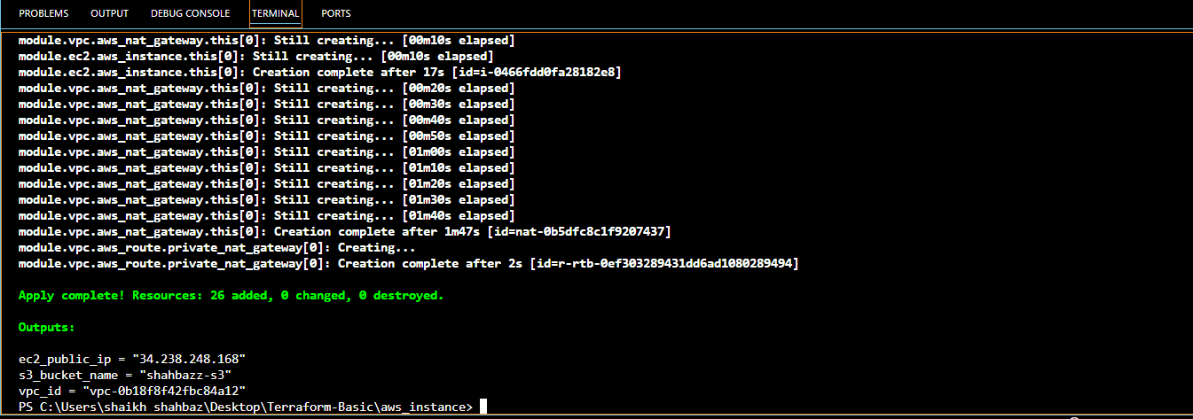
- Now we can check in our AWS account for Ec2
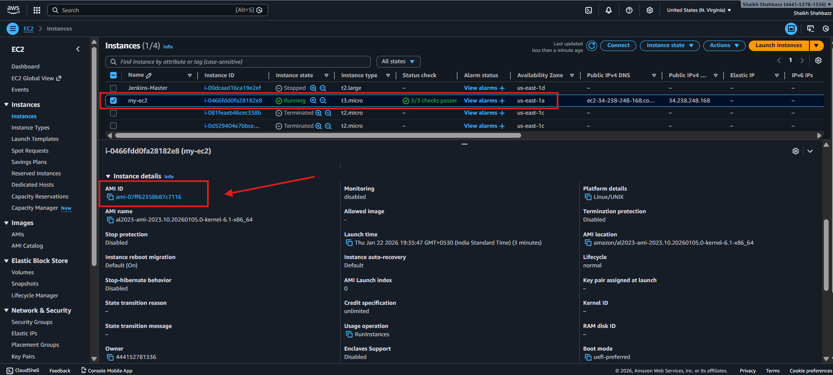
- And also we can check for S3 bucket with name < shahbaz-s3 >
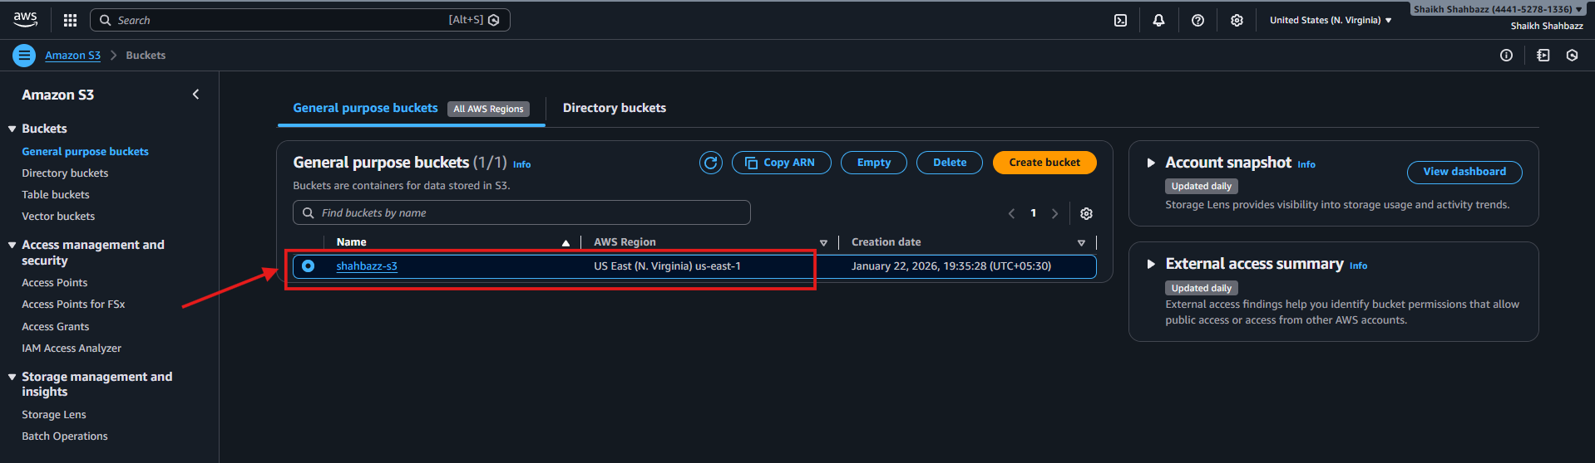
- Check for VPC with name < my-vpc >
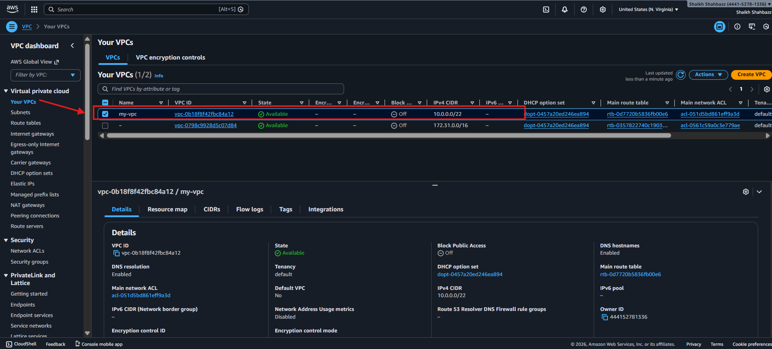
4. Provision EC2 for 3 different environments (Dev, Staging, and Prod) using Terraform workspaces.
main.tf
terraform {
required_version = ">= 1.3.0"

required_providers {
aws = {
source = "hashicorp/aws"
version = "~> 5.63"
}
}
}

provider "aws" {
region = "us-east-1"
}

locals {
env = terraform.workspace

instance_type_map = {
dev = "t3.micro"
staging = "t3.small"
prod = "t3.small"
}

instance_name_map = {
dev = "dev-ec2"
staging = "staging-ec2"
prod = "prod-ec2"
}
}

# Default VPC
data "aws_vpc" "default" {
default = true
}

# Default Subnet
data "aws_subnets" "default" {
filter {
name = "vpc-id"
values = [data.aws_vpc.default.id]
}
}

# Security Group
resource "aws_security_group" "sg" {
name = "${local.env}-sg"
description = "Security group for ${local.env} "
vpc_id = data.aws_vpc.default.id

tags = {
environment = local.env
}
}

# EC2 Instance
resource "aws_instance" "app" {
ami = "ami-07ff62358b87c7116"
instance_type = local.instance_type_map[local.env]

subnet_id = data.aws_subnets.default.ids[0]
vpc_security_group_ids = [aws_security_group.sg.id]

tags = {
Name = local.instance_name_map[local.env]
environment = local.env
}
}

output "environment" {
value = local.env
}

output "instance_type" {
value = aws_instance.app.instance_type
}

output "public_ip" {
value = aws_instance.app.public_ip
}
- terraform init
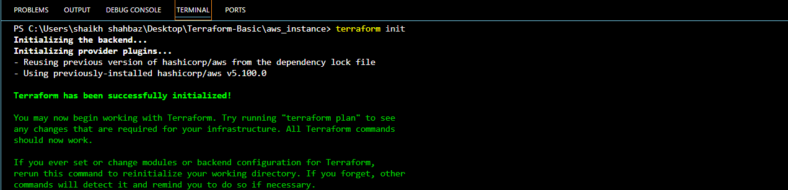
Now create workspaces for each Ec2
For : <dev> < staging > <prod>
Run below commands in terraform terminal:

- terraform workspace new dev
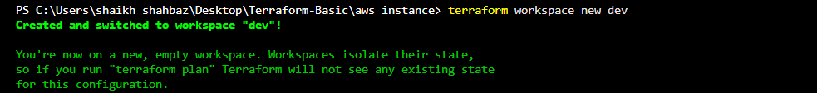
- terraform workspace new staging
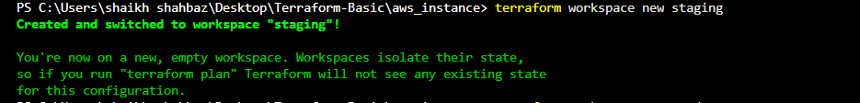
- terraform workspace new prod
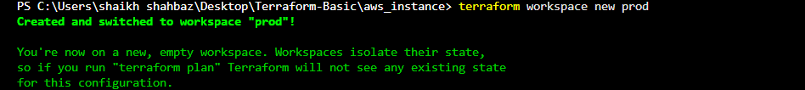

Check all terraform workspaces
- terraform workspace list
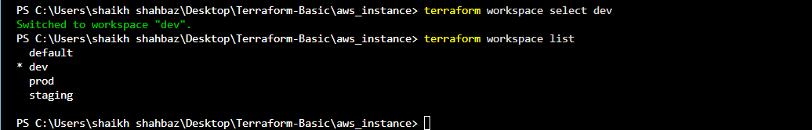
We need to switch to the specific workspace for terraform apply

- Provisioning Ec2 on Dev environment
Command to switch to workspaces in terraform < terraform workspace select (workspace name*)>
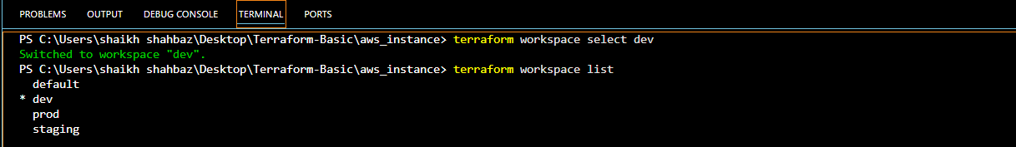
- terraform apply
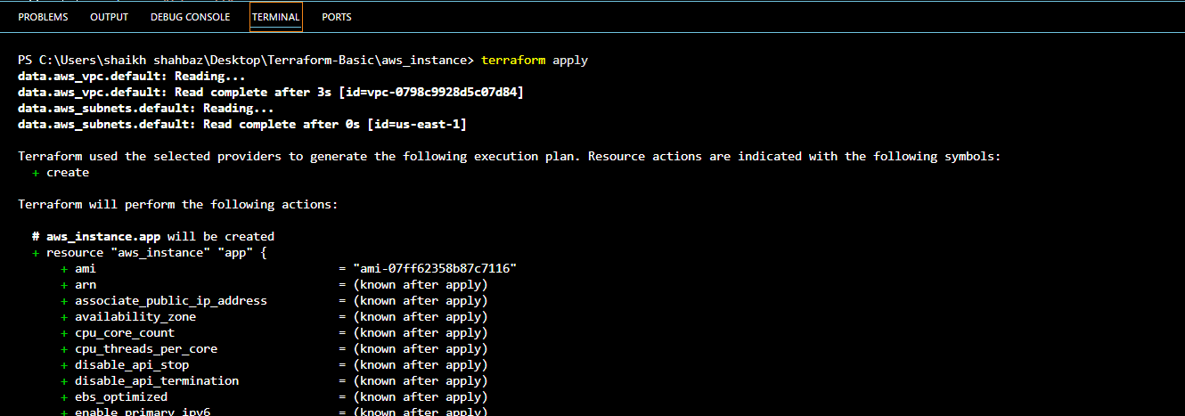
- Check for launched Ec2 in your AWS account
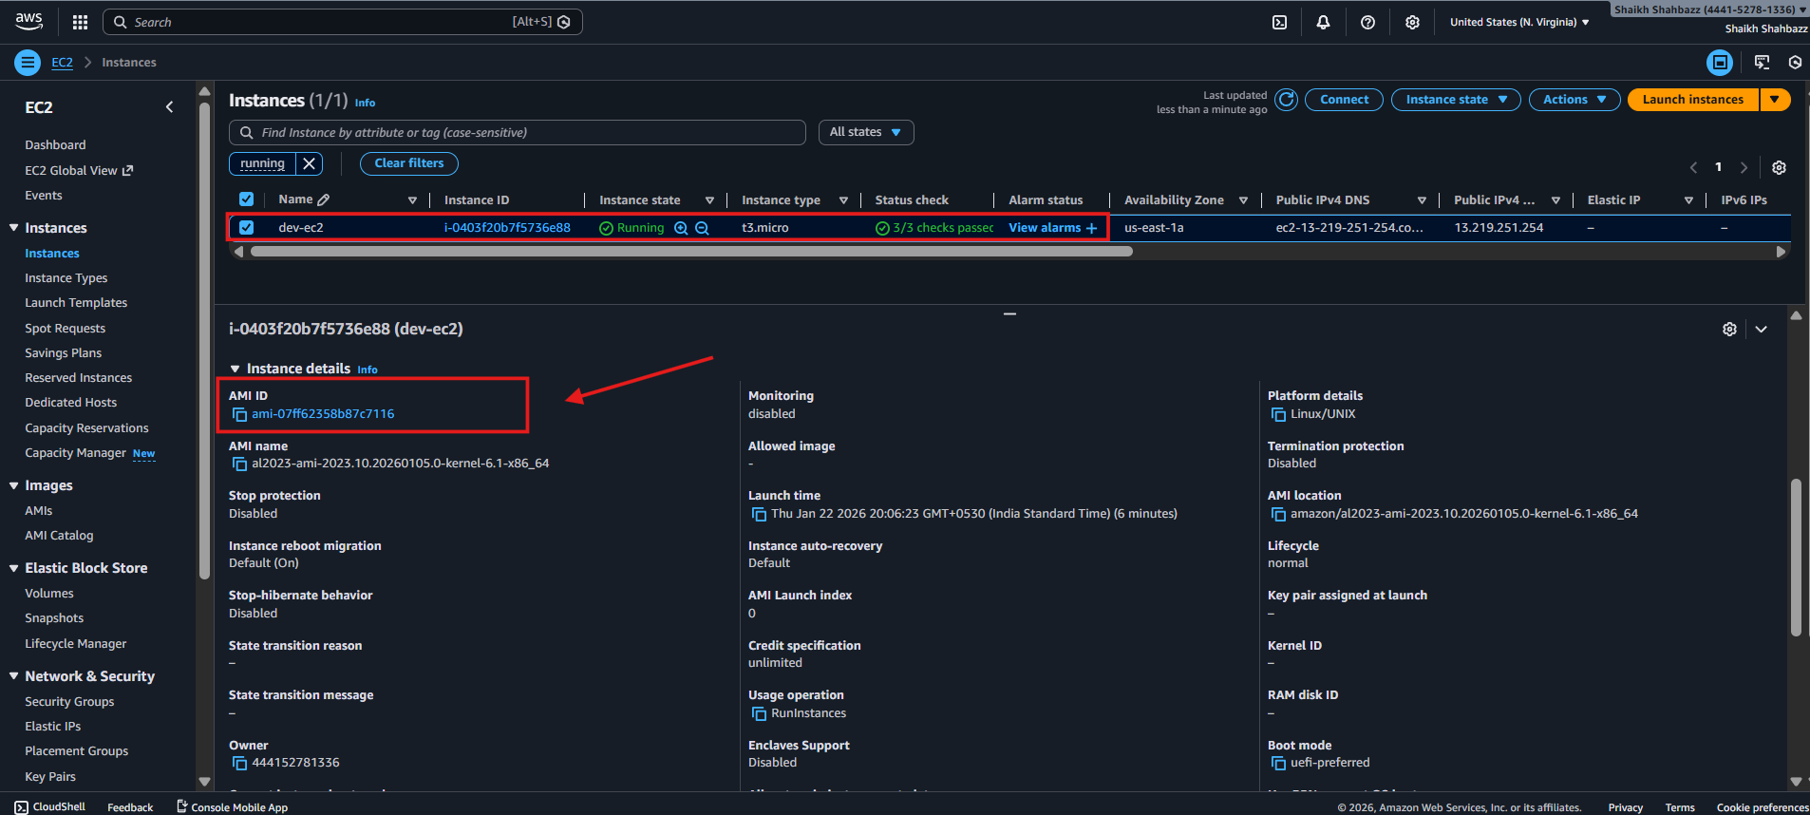
- Terraform output
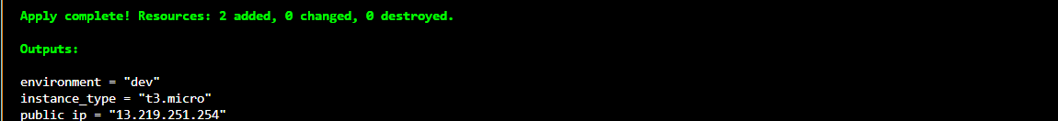

- Provisioning Ec2 on Staging environment
Command to switch to workspaces in terraform < terraform workspace select (workspace name*)>
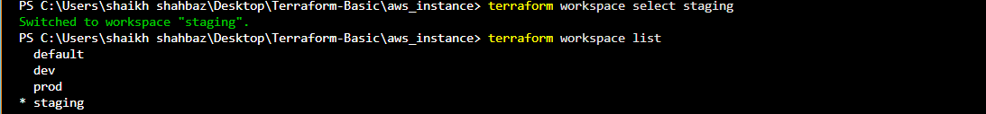
- terraform apply
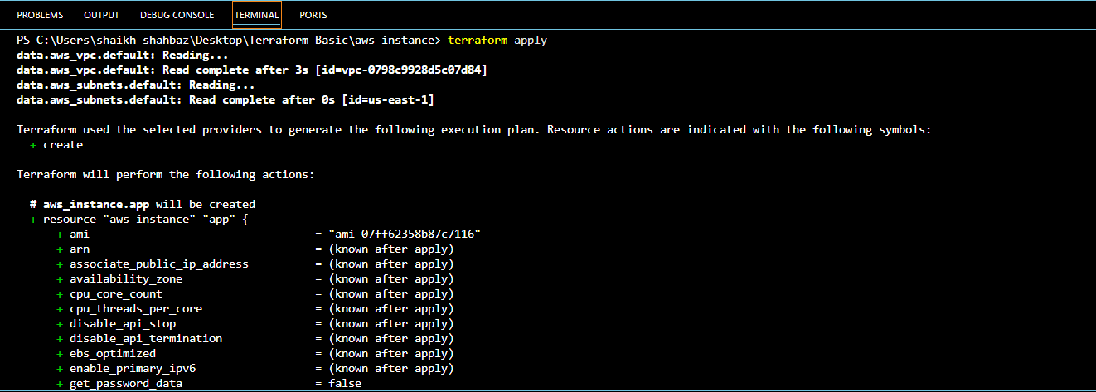

- Check for launched Ec2 in your AWS account
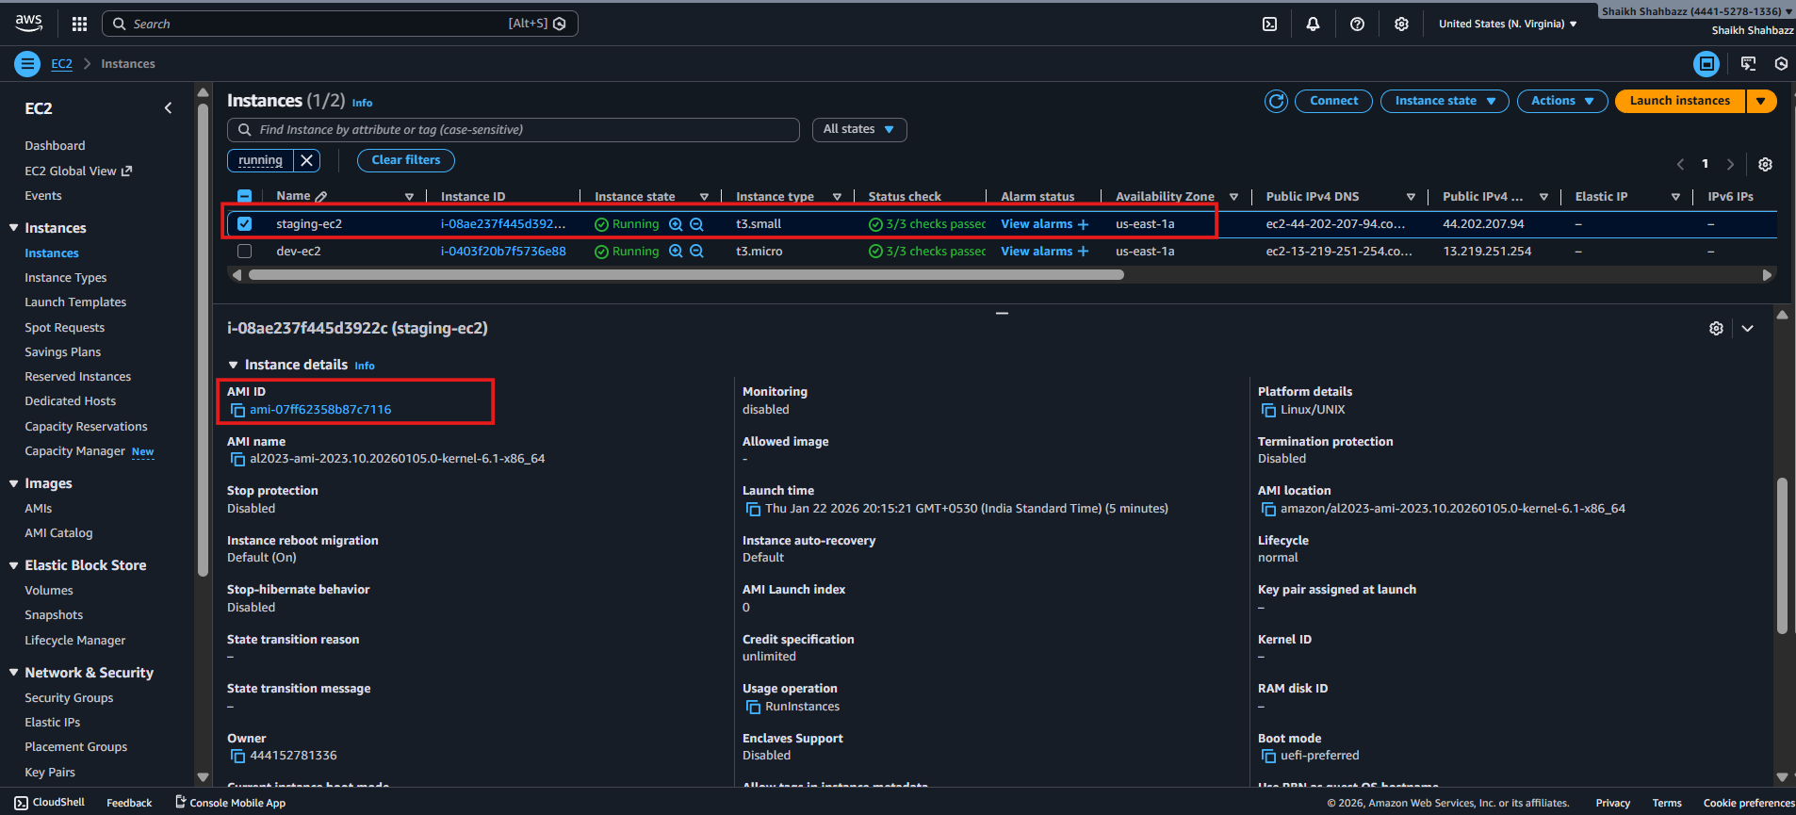
- Terraform output
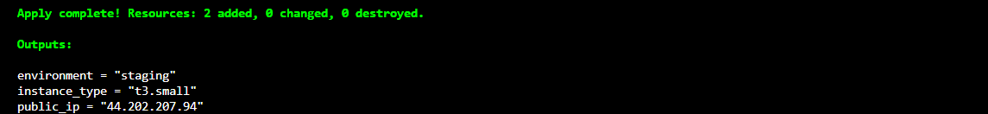

- Provisioning Ec2 on Prod environment
Command to switch to workspaces in terraform < terraform workspace select (workspace name*)>
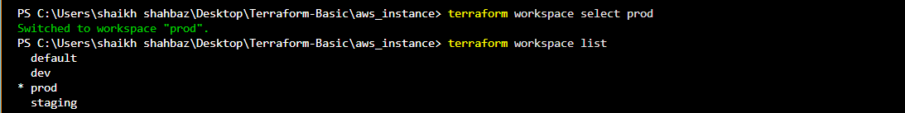

- terraform apply
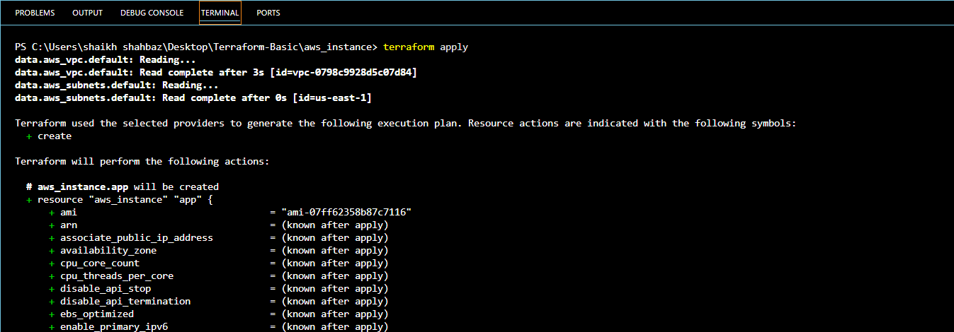

- Check for launched Ec2 in your AWS account
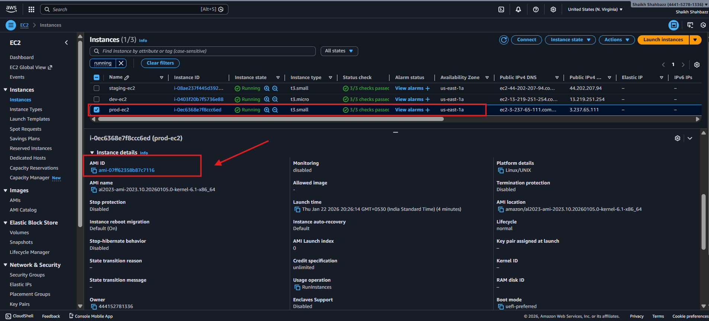

- Terraform output
